Group name | EUROPE CLIENT - LVADV01-2026-EUR-7D6N-HANOI-SAPA-LAO CHAI-TA VAN-SEO TRUNG HO-BAN HO-THANH PHU- SAPA BY NIGHT TRAIN | Code | 240919102822
Version | 1 | Sales consultant | Sales team
Group size | 2 - 20 pax(s) | Validity | 1 Jan 2026 – 31 Dec 2026

LVADV01-2026-EUR-7D6N-HANOI-SAPA-LAO CHAI-TA VAN-SEO TRUNG HO-BAN HO-THANH PHU- SAPA BY NIGHT TRAIN
LVADV01-2026-EUR-7D6N – HANOI – SAPA – LAO CHAI – TA VAN – SEO TRUNG HO – BAN HO – THANH PHU – SAPA EN TREN NOCTURNO
Day 1: Hanoi arrival, night train to Lao Cai (-/-/-)
Upon you arrival, we will pick up you and transfer to Hanoi city centre
In the evening, Meet our guide at hotel lobby. We will be traveling in a first class soft sleeper cabin up to Lao Cai. Train leaves Hanoi at night and arrive at Lao Cai station in the morning.


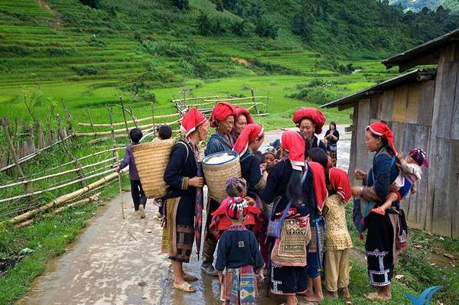

Vida local en Sapa
Overnight on night train
* Note: There are 4 soft sleeper berths in one cabin on train for Sapa Tour. Our quotation is based on 01pax/one berth. If your clients want to have a private cabin, please add the surcharge as below:
- 01 client in a private cabin => pay 3 the rest berths: 65USD*3 = 195 USD
- 02 clients in a private cabin => pay 2 the rest berths: 65USD*2= 130 USD
- 03 clients in a private cabin => pay 1 the rest berth: 65USD*1= 65USD
- 04 clients in a private cabin => No pay any surcharge
- English guide escort on night train
- SP3: Hanoi to Lao Cai: 22:00 – 05:55 +1 or similar (The train’s time can change without notice depend on every train. )

Día 1: Llegadad a Hanói – Tren nocturno a Lao Cai (-/-/-)
A su llegada, recogida y traslado al centro de la ciudad de Hanoi.
Por la noche, encuentro con nuestro guía en el lobby del hotel. Viajaremos en un camarote de primera clase con literas blandas hasta Lao Cai. El tren sale de Hanoi por la noche y llega a la estación de Lao Cai por la mañana.
Noche en tren nocturno.

Nota: Hay 4 literas blandas por cabina en el tren para el tour de Sapa. Nuestra cotización está basada en 01 pasajero / 01 litera. Si los clientes desean cabina privada, se aplicará el siguiente suplemento:
- 01 cliente en cabina privada: paga 3 literas restantes: 65 USD × 3 = 195 USD
- 02 clientes en cabina privada: paga 2 literas restantes: 65 USD × 2 = 130 USD
- 03 clientes en cabina privada: paga 1 litera restante: 65 USD × 1 = 65 USD
- 04 clientes en cabina privada: sin suplemento
- Guía acompañante de habla inglesa en el tren nocturno
SP3: Hanói – Lao Cai: 22:00 – 05:55 +1 o similar (el horario del tren puede cambiar sin previo aviso según cada tren)

Day 2: Sapa- Lao Chai - Ta Van Hill tribe Villages (B/L/D)
Meet our driver at Lao Cai Railway Station, we transfer to hotel for a shower, breakfast and morning coffee. We embark on a trek from Sapa town to Lao Chai and Ta Van villages, home to Black Mong and Day tribes. Tonight we spend a first night with local family.
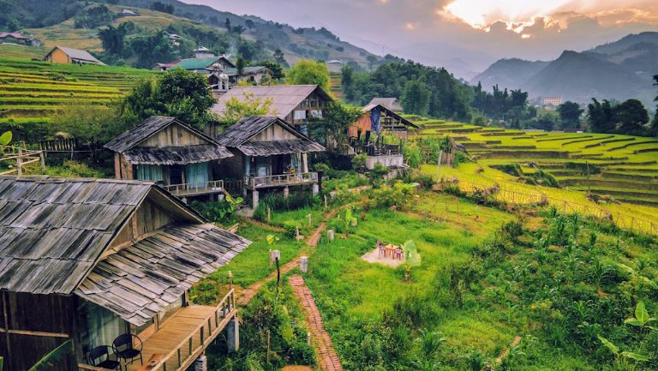
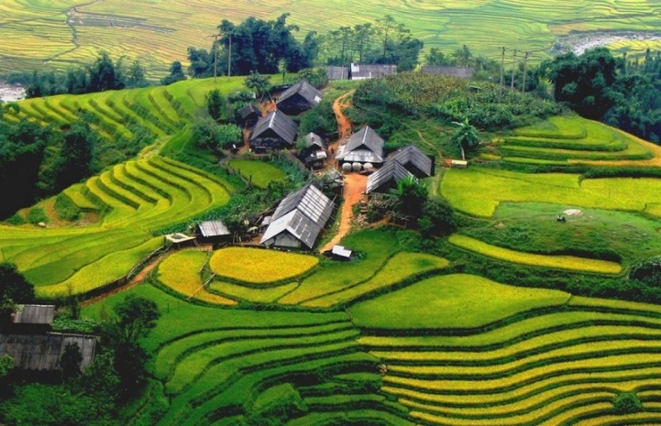

Aldea de Ta Van Casa de los H’Mong Negro
Overnight in homestay at Ta Van Village
* Note: From the town of Sapa – Ta Van Village: 15 km => 5- 6 hours for Hard trekking.

Día 2: Sapa – Aldeas tribales de Lao Chai y Ta Van (D/A/C)
Recepción por nuestro conductor en la estación ferroviaria de Lao Cai y traslado al hotel para ducha, desayuno y café matutino.
Inicio de la caminata desde el pueblo de Sapa hacia las aldeas de Lao Chai y Ta Van, hogar de las etnias H’Mong Negro y Day. Esta noche nos alojamos con una familia local.

Alojamiento: Homestay en la aldea de Ta Van
Nota: De Sapa a Ta Van: 15 km – 5 a 6 horas de trekking exigente

Day 3: Ta Van - Seo Trung Ho village (B/ L/ D)
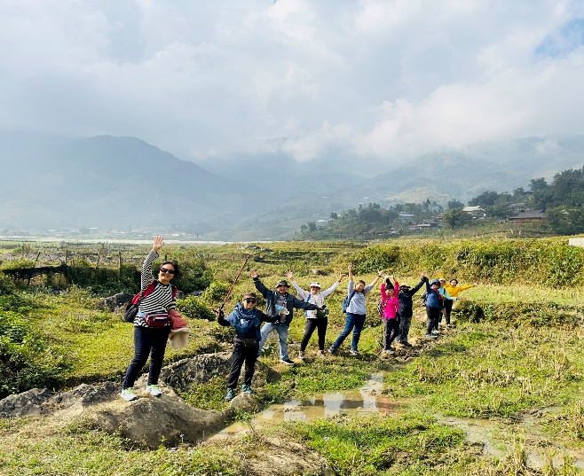
Trek of today is hard. We trek from the Village of Day to Seo
Trung Ho village of Red Dao village, it takes us around 6 hours , and most of time is up to mountain.

We encounter many tribes, rivers, rainforest. Our friendly
guide often said to us we go up to the heaven today and
down to the hell tomorrow.
Overnight in homestay at Seo Trung Ho village.
* Note: Ta Van Village – Seo Trung Ho Village: 15 km
=> 5- 6 hours for Hard trekking.

Treeking en aldea de la etnia Dao Rojo

Día 3: Ta Van – Aldea de Seo Trung Ho (D/A/C)
La caminata de hoy es difícil. Trekking desde la aldea del pueblo Day hasta Seo Trung Ho, hogar de la etnia Dao Rojo. El recorrido dura unas 6 horas, en su mayor parte en ascenso por la montaña.
Durante el trayecto encontramos diversas etnias, ríos y selva tropical. Nuestro amable guía suele decir: “Hoy subimos al cielo y mañana bajamos al infierno.”
Alojamiento: Homestay en la aldea de Seo Trung Ho
Nota: Ta Van – Seo Trung Ho: 15 km – 5 a 6 horas de trekking exigente

Day 4: Seo Trung Ho - Ban Ho Hill tribe Villages (B/L/ D)
We have full day trek from Seo Trung Ho village that will take us along buffalo paths and trails and through several hill tribe villages. This is an absolutely spectacular walk through stunning scenery inhabited by some of the friendliest people you will meet. Stopping for a picnic lunch on the way we will spend the night with a family in Ban Ho village, inhabited by the Tay ethnic minority.
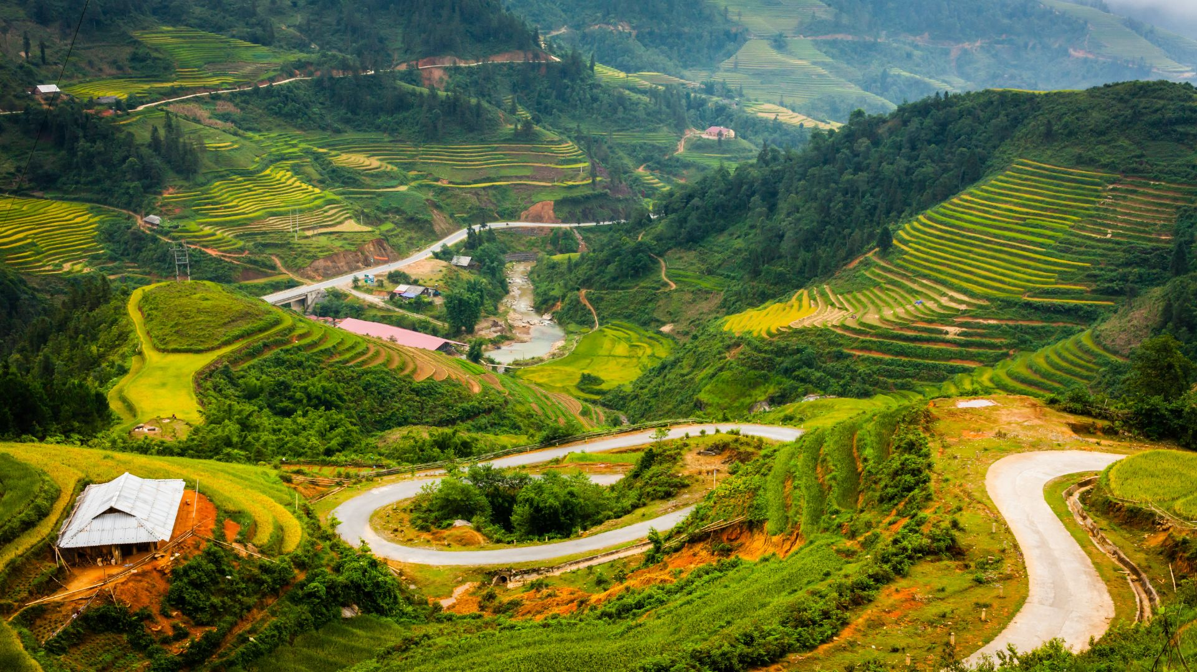

Aldea de Ban Ho

Overnight in homestay at Ban Ho village
* Note: Seo Trung Ho Village – Ban Ho village: 15 km => 5- 6 hours for Hard trekking.

Día 4: Seo Trung Ho – Aldeas tribales de Ban Ho (D/A/C)
Trekking de día completo desde Seo Trung Ho, siguiendo senderos de búfalos y caminos rurales que atraviesan varias aldeas étnicas. Es una caminata espectacular a través de paisajes impresionantes, habitados por algunas de las personas más hospitalarias que conocerá.
Parada para almuerzo tipo picnic durante el recorrido. Por la noche, alojamiento con una familia local en Ban Ho, habitada por la etnia Tay.
Alojamiento: Homestay en la aldea de Ban Ho
Nota: Seo Trung Ho – Ban Ho: 15 km – 5 a 6 horas de trekking exigente

Day 5: Ban Ho Village - Thanh Phu Village (B/L/D)
After enjoying breakfast we depart for a 3-hour trek to Thanh Phu village, home of Tay people. Check in our guest for tonight first then we head out for a walk to My Son, Nam Sai, Nam Cang, Nam Nhiu villages, home of numerous tribes including Tay , Red Dao, and Xa Pho. We trek back to our Thanh Phu village. We stay in their traditional long house on stilts.

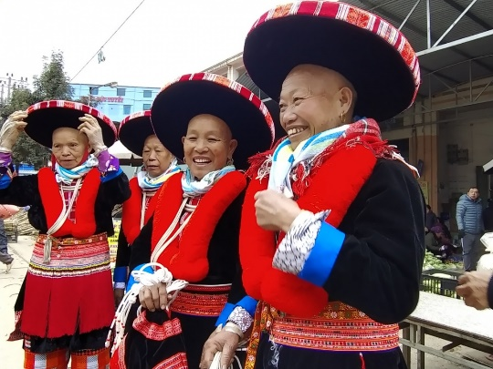
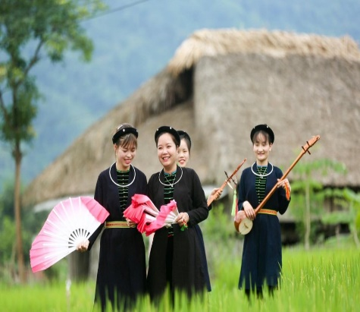
Tay – minoría étnica Dao Rojo – minoría étnica Xa Pho – minoría étnica

Overnight in homestay at Thanh Phu village
* Note: Ban Ho village – Thanh Phu village: 10 km => 2 - 3 hours for Hard trekking.

Día 5: Ban Ho – Aldea de Thanh Phu (D/A/C)
Después del desayuno, salida para una caminata de unas 3 horas hacia la aldea de Thanh Phu, hogar del pueblo Tay.
Registro en la casa local y continuación de la caminata hacia las aldeas de My Son, Nam Sai, Nam Cang y Nam Nhiu, habitadas por diversas etnias como Tay, Dao Rojo y Xa Pho. Regreso a Thanh Phu. Alojamiento en una casa tradicional sobre pilotes.

Alojamiento: Homestay en la aldea de Thanh Phu
Nota: Ban Ho – Thanh Phu: 10 km – 2 a 3 horas de trekking exigente

Day 6: Thanh Phu - Sapa – Night train to Hanoi (B/L/-)
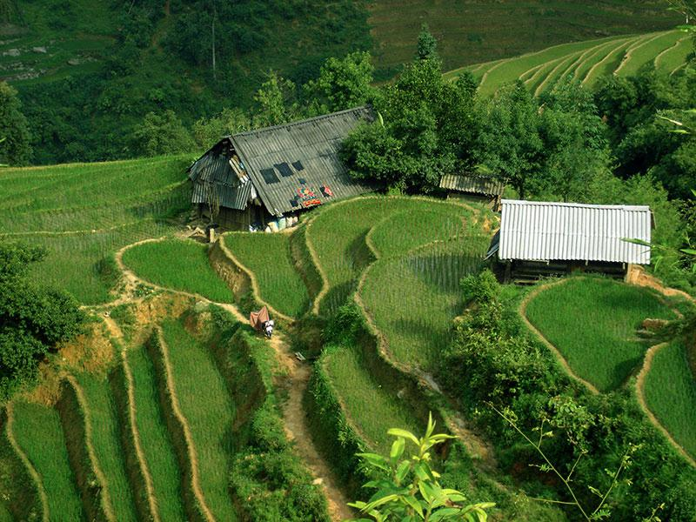
Bidding farewell to our graceful host in Thanh Phu and its friendly people we head back to Sapa town. We have lunch here and then last minutes to shop before transfer to Lao Cai Railway to catch the night train to Hanoi .
Thanh Phu - Sapa

Overnight on night train
* Note: There are 4 soft sleeper berths in one cabin on train for Sapa Tour. Our quotation is based on 01pax/one berth. If your clients want to have a private cabin, please add the surcharge as below:
- 01 client in a private cabin => pay 3 the rest berths: 65USD*3 = 195 USD
- 02 clients in a private cabin => pay 2 the rest berths: 65USD*2= 130 USD
- 03 clients in a private cabin => pay 1 the rest berth: 65USD*1= 65USD
- 04 clients in a private cabin => No pay any surcharge
- English guide escort on night train
- SP4: Lao Cai to Hanoi: 21:30 – 05:35 +1 or similar (The train’s time can change without notice depend on every train. )
Día 6: Thanh Phu – Sapa – Tren nocturno a Hanói (D/A/-)
Despedida de nuestros amables anfitriones y de la gente de Thanh Phu. Regreso a Sapa, almuerzo en el pueblo y tiempo libre para compras antes del traslado a la estación ferroviaria de Lao Cai para tomar el tren nocturno de regreso a Hanói.
Alojamiento: Tren nocturno

Nota: Hay 4 literas blandas por cabina en el tren para el tour de Sapa. Nuestra cotización está basada en 01 pasajero / 01 litera. Si los clientes desean cabina privada, se aplicará el siguiente suplemento:
- 01 cliente en cabina privada: paga 3 literas restantes: 65 USD × 3 = 195 USD
- 02 clientes en cabina privada: paga 2 literas restantes: 65 USD × 2 = 130 USD
- 03 clientes en cabina privada: paga 1 litera restante: 65 USD × 1 = 65 USD
- 04 clientes en cabina privada: sin suplemento
- Guía acompañante de habla inglesa en el tren nocturno
SP4: Lao Cai – Hanoi: 21:30 – 05:35 +1 o similar (el horario del tren puede cambiar sin previo aviso según cada tren)

Day 7: Hanoi departure (B/-/-)
The train arrives in Ha Noi early morning. Our guide arranges a transfer to your hotel to relax
Our tour guide will drop you off at airport for departure flight.
- Important notes:
- This is an off beaten track walk, which is very good for clients who wish to get away from crowds at touristic places.
- What to bring: Good trekking boots, rainwear, 2 sets of clothes, socks, towel, swimming suit, Camera and film, flash light, Medicine for personal use.
- Best time to trek:from March to May when it is dry and clean; and from September to November if you want to enjoy the terraces
- Return train ticket Hanoi – Lao Cai – Hanoi (4 pax share in one cabin, soft berth. If your group is odd, please share with other tourists OR pay more to get private cabin on train).
- Normally, the trekking time is about 5- 10 km per day. Depend on your healthy, our itinerary can be flexible to meet your ideas during the trip.
End of services
Día 7: Llegada a Hanói (D/-/-)
Llegada a Hanói temprano por la mañana. Nuestro guía organizará el traslado al hotel para descansar. Luego, nuestro guía lo trasladará al aeropuerto para su vuelo de salida.
Notas importantes:
- Este es un itinerario fuera de los circuitos turísticos habituales, ideal para viajeros que desean alejarse de las multitudes.
- Qué llevar: botas de trekking adecuadas, impermeable, 2 mudas de ropa, calcetines, toalla, traje de baño, cámara, linterna y medicación de uso personal.
- Mejor época para el trekking: De marzo a mayo, clima seco y limpio; de septiembre a noviembre, para disfrutar de las terrazas de arroz
- Billete de tren ida y vuelta Hanói – Lao Cai – Hanói (4 pasajeros compartiendo una cabina con literas blandas). Si el grupo es impar, se compartirá con otros viajeros o se deberá pagar suplemento para cabina privada.
- Normalmente, la distancia diaria de trekking es de 5 a 10 km. Dependiendo de la condición física de los participantes, el itinerario puede adaptarse de forma flexible durante el viaje.
Fin de servicios

List of accommodations
Lista de alojamientos
Location  Ubicación | Home stay  Homestay | Room/ cabin category  Categoría de habitación o cabaña
Lao Cai | In Ta Van | Sharing local community house  Compartiendo casa comunitaria local
Lao Cai | In Seo Trung Ho | Sharing local community house  Compartiendo casa comunitaria local
Lao Cai | In Ban Ho | Sharing local community house  Compartiendo casa comunitaria local
 | In Thanh Phu | Sharing local community house  Compartiendo casa comunitaria local

Rates and Conditions
Prices are in USD per person, based on two guests sharing a twin or double room in the hotels mentioned above.
Below rates are not valid for the period of Christmas, New Year (normally from 20 Dec to 10/ 15 Jan), Vietnamese New Year (16 Feb – 26 Feb), Independence Day (30 April), May Day (1 May), National Day (02 Sep), etc. Please contact us for further details in terms of specific dates.
Tarifas y condiciones
Los precios están expresados ​​en dólares estadounidenses por persona, en base a dos huéspedes compartiendo habitación doble o twin en los hoteles mencionados.
Las tarifas a continuación no son válidas para Navidad, Año Nuevo (normalmente del 20 de diciembre al 10/15 de enero), Año Nuevo chino/vietnamita, Día de la Independencia (30 de abril), Primero de Mayo, Día Nacional (2 de septiembre), entre otros. Para más información sobre fechas específicas, contáctenos.

Low = High =2026
Temporada alta = Temporada baja = 2026
Group size/ Price per person  Tamaño del grupo/Precio por persona | 2 | 3 | 4 | 5-7 | 8-9 | 10-15 | 16-20
Home stay | 1,257 | 1,237 | 1,047 | 932 | 778 | 690 | 676

Inclusions | Exclusions
  • Sharing homestay in Sapa with local breakfast with 01 noddle and 01 drink
  • Meals as mentioned in the program: L=Lunch, D=Dinner Base on Vietnamese Food
  • Transfer from and to the airports by private vehicle with A/C. Transportation by private vehicle with A/C.
  • Superior train Hanoi – Lao Cai and Lao Cai – Hanoi. Air-conditioned cabin with soft sleeper berths (04pax/cabin sharing).
  • All entrance fees and sightseeing as mentioned in the program.
  • Local English speaking guide(s) as mentioned
  • FOC in ½ Twin room for group of 15 paying pax onward (excluding internal airfares and visas). Maximum 01 FOC per group.
  • Surchager if you want private cabin on train
  • Meals and drinks which are not mentioned in the program
  • Surcharge for train Hanoi – Sapa//Sapa - Hanoi
  - Surcharge 30$ for 1 ticket/1 way
  - Surcharge 60$ for 2 tickets/1 way
  - Surcharge 88.5 $ for 3 tickets/1 way
  • International flight tickets and airport taxes. All internal/ regional flight tickets in economy class
  • TIPPING for local guide and van driver
  * 1 pax: 15 USD/ pax/ day
  * 2 - 4 pax: 10 USD/ pax/ day
  * 5 pax: 6 USD/ pax/ day
  *Suggested TIPPING for bellboy, boat crew, sampan driver: depend on your satisfication
  • Visa arrangement
  • Tips & personal expenses. Personal insurance. Any services not clearly mentioned in the program

Incluidos | Excluidos
• Alojamiento en homestay compartido en Sapa, con desayuno local incluido (01 fideo y 01 bebida).  • Comidas según lo mencionado en el programa: D=  Desayuno, A= Almuerzo, C= Cena, basadas en comida vietnamita.  • Traslados desde y hacia los aeropuertos en vehículo privado con aire acondicionado. Transporte terrestre en vehículo privado con aire acondicionado.  • Tren superior Hanói – Lao Cai y Lao Cai – Hanói, cabina climatizada con literas blandas (04 pax/cabina compartida).  • Entradas y visitas turísticas según lo mencionado en el programa  • Guía(s) local(es) de habla inglesa según lo  mencionado  • FOC en ½ habitación doble para grupos a partir de 15 pasajeros de pago (excluyendo vuelos internos y visados). Máximo 01 FOC por grupo. | • Suplemento por cabina privada en el tren, si se solicita.  • Comidas y bebidas no mencionadas en el programa  • Recargo por tren Hanói – Sapa//Sapa – Hanói  - Suplemento 30 USD por 1 billete / 1 trayecto  - Suplemento 60 USD por 2 billetes / 1 trayecto  - Suplemento 88,5 USD por 3 billetes / 1 trayecto  • Billetes de vuelos internacionales y tasas aeroportuarias. Todos los vuelos internos/regionales en clase económica.  • PROPINAS para el guía local y el conductor de la  furgoneta  * 1 persona: 15 USD cada persona por día  * 2-4 personas: 10 USD cada persona por día  * A partir de 5 personas: 6 USD cada persona por día  *Propinas sugeridas para botones, tripulación del  barco y conductor del sampán: según su satisfacción  • Tasas de visado a la llegada a Vietnam.  • Propinas y gastos personales. Seguro personal. Cualquier servicio no mencionado claramente en el programa.

GENERAL TERMS & CONDITIONS
Remarks for check in and check out schedules
Check in time: at hotel: after 14h00
Check out time: at hotel before 12h00.
Remarks for itinerary
The itinerary and schedule are subject to change due to local traffic situations, weather conditions; flight, or any un-foreseen circumstances or local authority decision. LV Travel reserves full rights to replace all items with same values for guests.
Remarks for meal
Meals are fusion on local food with daily normal buffet breakfast at hotel. Guests should advise any special food preferences, allergies or dietary requirements at least one (1) week prior to the arrival date.
Remarks for the price
16 full paying pax group is granted one FOC based on half twin sharing room (exclusive of extra service).
Please be aware that any changes in the itinerary due to unforeseen circumstances might result in increase in pricing.
Any damage caused to all services during the stay shall be payable by the passengers.
Validity
All prices quoted to the Client/Agent are on a net basis in United States Dollars and valid according to the date specified on the LV Travel printed tariffs and/or quotation and/or invoice issued to the Client/Agent. LV Travel warrants that the prices or rates quoted to the Client/Agent are correct at the time of issuance or invoice but are subject to change in line with market, tax or currency fluctuation, with or without prior notice.
Payment method
Unless otherwise agreed by LV Travel, client’s payment shall be executed by bank transfer, to the LV travel’s bank account clearly noted in all the invoices. Every party shall take care of the transfer fees occurring with its relevant bank.
Payment conditions for domestic or international flights : We will check case by case.
Payment conditions for land tour without flights:
- In general there is no Deposit required. LV Travel reserves its right to forward deposit requests from suppliers in case they occur.
- The full payment of 100% of the total price must be transferred to the LV Travel account 30 days prior to the group arrival in Indochina, if not agreed otherwise.
Cancellation of domestic or international flights: We will check case by case.
Cancellation policy for land tour without flights:
- All cancellations should be made in writing and should be acknowledged by LV travel.
-Cancellation Rules for Land Tour, not apply for domestic or international flights (if any).
- Cancellation more than 45 days prior to the group arrival: No Charge. Deposit shall be deducted into the next bookings, except specified suppliers require cancellation fees
- Cancellation between the 45th and 31st day prior to the group arrival: 25% of the total tour price.
- Cancellation between the 30th and 23rd day prior to the group arrival: 30% of the total tour price.
- Cancellation between the 22nd and 16th day prior to the group arrival: 40% of the total tour price.
- Cancellation between the 15nd and 09th day prior to the group arrival: 60% of the total tour price.
- Cancellation between the 08nd and 03rd day prior to the group arrival: 80% of the total tour price.
- Cancellation between the 02nd and 0th day prior to the group arrival: 100% of the total tour price..
- In case the tour participant(s) shorten or interrupt the tour of their own accord there will be no reimbursements.
- Reduction in the number of passengers against requested bookings is considered and treated as cancellations.
- If the balance of the tour invoice is not received by the deadline of 15days prior to the group arrival, LV Travel will reserve the right to cancel the reservation without indemnity or any reimbursement.
- If LV Travel is forced to cancel the departure due to unforeseeable reasons, the participants will be fully reimbursed without intention to claim for any indemnities.

Contact details
Hotline for sales (ms Moon) | +84 888 905 286 (WA/viber/mobile)
Hotline for operation (ms Anna Hanh) | +84 983 096 032(WA/viber/mobile)
General Manager Mr Len | +84 989 200 116 (WA/viber/mobile)

TÉRMINOS Y CONDICIONES GENERALES

Información sobre los horarios de entrada y salida
Hora de entrada: en el hotel: después de las 14:00 h - en el crucero: antes de las 12:00 h.
Hora de salida: en el hotel y en el crucero: antes de las 12:00 h.

Información sobre el itinerario
El itinerario y el horario están sujetos a cambios debido a la situación del tráfico local, las condiciones meteorológicas, el vuelo, cualquier circunstancia imprevista o decisión de las autoridades locales. LV Travel se reserva el derecho de reemplazar todos los artículos por el mismo precio para los huéspedes.

Información sobre las comidas
Las comidas son una fusión de platos locales con desayuno buffet diario en el hotel. Los huéspedes deben informar sobre cualquier preferencia alimentaria, alergia o requisito dietético especial con al menos una (1) semana de antelación a la fecha de llegada.

Información sobre el precio
A los grupos de 16 personas que pagan la tarifa completa se les otorga una habitación compartida (sin incluir servicios adicionales).
Tenga en cuenta que cualquier cambio en el itinerario debido a circunstancias imprevistas podría resultar en un aumento de precios.
Cualquier daño causado a los servicios durante la estancia será responsabilidad de los pasajeros.

Validez
Todos los precios cotizados al Cliente/Agente son netos en dólares estadounidenses y válidos según la fecha especificada en las tarifas impresas de LV Travel, la cotización o la factura emitida al Cliente/Agente. LV Travel garantiza que los precios o tarifas cotizadas al Cliente/Agente son correctos al momento de la emisión de la factura, pero están sujetos a cambios según las fluctuaciones del mercado, los impuestos o la moneda, con o sin previo aviso.

Método de pago
Salvo acuerdo en contrario con LV Travel, el pago del cliente se realizará mediante transferencia bancaria a la cuenta bancaria de LV Travel claramente indicada en todas las facturas. Cada parte se hará cargo de los gastos de transferencia con su banco correspondiente.

Condiciones de pago para vuelos nacionales o internacionales: Se revisará cada caso individualmente.
Condiciones de pago para tours terrestres sin vuelos:
- Generalmente, no se requiere depósito. LV Travel se reserva el derecho de reenviar las solicitudes de
depósito de los proveedores en caso de que se produzcan.
- El pago completo del 100% del precio total debe transferirse a la cuenta de LV Travel 30 días antes de la llegada del grupo a Indochina, salvo acuerdo en contrario.
Cancelación de vuelos nacionales o internacionales: Se revisará cada caso individualmente.
Política de cancelación para tours terrestres sin vuelos
- Todas las cancelaciones deben realizarse por escrito y LV Travel debe confirmar su recepción.
- Las normas de cancelación para tours terrestres no aplican para vuelos nacionales o internacionales (si los hubiera).
- Cancelación con más de 45 días de antelación a la llegada del grupo: Sin cargo. El depósito se descontará de las siguientes reservas, excepto en el caso de proveedores específicos que requieran cargos por cancelación.
- Cancelación entre el 45 y el 31 días antes de la llegada del grupo: 25% del precio total del tour.
- Cancelación entre el 30 y el 23 días antes de la llegada del grupo: 30% del precio total del tour.
- Cancelación entre el 22 y el 16 días antes de la llegada del grupo: 40% del precio total del tour.
- Cancelación entre el 15 y el 9 días antes de la llegada del grupo: 60% del precio total del tour.
- Cancelación entre el 8 y el 3 días antes de la llegada del grupo: 80% del precio total del tour.
- Cancelación entre el 2 y el 0 días antes de la llegada del grupo: 100% del precio total del tour.

- En caso de que el/los participante(s) del tour acorten o interrumpan el tour por decisión propia, no se realizarán reembolsos. - La reducción del número de pasajeros respecto a las reservas solicitadas se considera una cancelación.
- Si el saldo de la factura del tour no se recibe dentro de los 15 días previos a la llegada del grupo, LV Travel se reserva el derecho de cancelar la reserva sin indemnización ni reembolso alguno.
- Si LV Travel se ve obligado a cancelar la salida por causas imprevistas, los participantes recibirán un reembolso completo sin derecho a reclamar indemnización alguna.

Contacto detallado
Línea directa de ventas (Sra. Moon) | +84 888 905 286 (WA/Viber/móvil)
Línea directa de operaciones (Sra. Anna Hanh) | +84 983 096 032(WA/viber/ móvil)
Gerente general, Sr. Len | +84 989 200 116 (WA/viber/ móvil)

